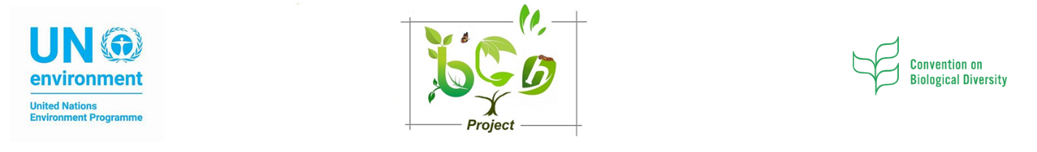

Biosafety Clearing House Project – Phase 3
UNEP-GEF Project for Sustainable Capacity Building for Effective Participation in the BCH

2nd National BCH Workshop
Angola
June 22-24, 2021

Group Work No. 3
(Training Materials that Need to be developed)

Identifying new courses /modules needed for sustainability of BCH capacity building | - New
Identify tools to be used for online and offline delivery courses /modules | - Online  - Offline

Group No. ____
Members:

